***PUBLIC HEALTH AWARENESS***

***NAME : BIPUL PANDEY***

***REG NO : 620821104020***

***DEPT : CSE(A SECTION)***

***COLLEGE CODE : 6208***

***COLLEGE NAME : GNANAMANI COLLEGE OF TECHNOLOGY***

***SKILLUP ID : bipul9162866323@gmail.com***

**CODING PART USING PYTHON :**

import numpy as np # linear algebra

import pandas as pd # data processing, CSV file I/O (e.g. pd.read_csv)

import matplotlib.pyplot as plt

import seaborn as sns

from scipy import stats

from scipy.stats import randint

# prep

from sklearn.model_selection import train_test_split

from sklearn import preprocessing

from sklearn.datasets import make_classification

from sklearn.preprocessing import binarize, LabelEncoder, MinMaxScaler

# models

from sklearn.linear_model import LogisticRegression

from sklearn.tree import DecisionTreeClassifier

from sklearn.ensemble import RandomForestClassifier, ExtraTreesClassifier

# Validation libraries

from sklearn import metrics

from sklearn.metrics import accuracy_score, mean_squared_error, precision_recall_curve

from sklearn.model_selection import cross_val_score

#Neural Network

from sklearn.neural_network import MLPClassifier

#Bagging

from sklearn.ensemble import BaggingClassifier, AdaBoostClassifier

from sklearn.neighbors import KNeighborsClassifier

#Naive bayes

from sklearn.naive_bayes import GaussianNB

#Stacking

from mlxtend.classifier import StackingClassifier

# Any results you write to the current directory are saved as output.

#reading in CSV's from a file path

train_df = pd.read_csv("C:\\Users\harsh\OneDrive\Desktop\Trainings 2023-2024\Firebird\DataSets\survey.csv")

#Pandas: whats the data row count?

print(train_df.shape)

#Pandas: whats the distribution of the data?

print(train_df.describe())

#Pandas: What types of data do i have?

print(train_df.info())

pip install mlxtend

#dealing with missing data

#Let’s get rid of the variables "Timestamp",“comments”, “state” just to make our lives easier.

train_df = train_df.drop(['comments'], axis= 1)

train_df = train_df.drop(['state'], axis= 1)

train_df = train_df.drop(['Timestamp'], axis= 1)

train_df.isnull().sum().max() #just checking that there's no missing data missing...

train_df.head(5)

# Assign default values for each data type

defaultInt = 0

defaultString = 'NaN'

defaultFloat = 0.0

# Create lists by data tpe

intFeatures = ['Age']

stringFeatures = ['Gender', 'Country', 'self_employed', 'family_history', 'treatment', 'work_interfere',

'no_employees', 'remote_work', 'tech_company', 'anonymity', 'leave', 'mental_health_consequence',

'phys_health_consequence', 'coworkers', 'supervisor', 'mental_health_interview', 'phys_health_interview',

'mental_vs_physical', 'obs_consequence', 'benefits', 'care_options', 'wellness_program',

'seek_help']

floatFeatures = []

# Clean the NaN's

for feature in train_df:

if feature in intFeatures:

train_df[feature] = train_df[feature].fillna(defaultInt)

elif feature in stringFeatures:

train_df[feature] = train_df[feature].fillna(defaultString)

elif feature in floatFeatures:

train_df[feature] = train_df[feature].fillna(defaultFloat)

else:

print('Error: Feature %s not recognized.' % feature)

train_df.head(5)

#clean 'Gender'

#Slower case all columm's elements

gender = train_df['Gender'].str.lower()

#print(gender)

#Select unique elements

gender = train_df['Gender'].unique()

#Made gender groups

male_str = ["male", "m", "male-ish", "maile", "mal", "male (cis)", "make", "male ", "man","msle", "mail", "malr","cis man", "Cis Male", "cis male"]

trans_str = ["trans-female", "something kinda male?", "queer/she/they", "non-binary","nah", "all", "enby", "fluid", "genderqueer", "androgyne", "agender", "male leaning androgynous", "guy (-ish) ^_^", "trans woman", "neuter", "female (trans)", "queer", "ostensibly male, unsure what that really means"]

female_str = ["cis female", "f", "female", "woman", "femake", "female ","cis-female/femme", "female (cis)", "femail"]

for (row, col) in train_df.iterrows():

if str.lower(col.Gender) in male_str:

train_df['Gender'].replace(to_replace=col.Gender, value='male', inplace=True)

if str.lower(col.Gender) in female_str:

train_df['Gender'].replace(to_replace=col.Gender, value='female', inplace=True)

if str.lower(col.Gender) in trans_str:

train_df['Gender'].replace(to_replace=col.Gender, value='trans', inplace=True)

#Get rid of bullshit

stk_list = ['A little about you', 'p']

train_df = train_df[~train_df['Gender'].isin(stk_list)]

print(train_df['Gender'].unique())

#complete missing age with mean

train_df['Age'].fillna(train_df['Age'].median(), inplace = True)

# Fill with media() values < 18 and > 120

s = pd.Series(train_df['Age'])

s[s<18] = train_df['Age'].median()

train_df['Age'] = s

s = pd.Series(train_df['Age'])

s[s>120] = train_df['Age'].median()

train_df['Age'] = s

#Ranges of Age

train_df['age_range'] = pd.cut(train_df['Age'], [0,20,30,65,100], labels=["0-20", "21-30", "31-65", "66-100"], include_lowest=True)

#There are only 0.014% of self employed so let's change NaN to NOT self_employed

#Replace "NaN" string from defaultString

train_df['self_employed'] = train_df['self_employed'].replace([defaultString], 'No')

print(train_df['self_employed'].unique())

#There are only 0.20% of self work_interfere so let's change NaN to "Don't know

#Replace "NaN" string from defaultString

train_df['work_interfere'] = train_df['work_interfere'].replace([defaultString], 'Don\'t know' )

print(train_df['work_interfere'].unique())

#Encoding data

labelDict = {}

for feature in train_df:

le = preprocessing.LabelEncoder()

le.fit(train_df[feature])

le_name_mapping = dict(zip(le.classes_, le.transform(le.classes_)))

train_df[feature] = le.transform(train_df[feature])

# Get labels

labelKey = 'label_' + feature

labelValue = [*le_name_mapping]

labelDict[labelKey] =labelValue

for key, value in labelDict.items():

print(key, value)

#Get rid of 'Country'

train_df = train_df.drop(['Country'], axis= 1)

train_df.head()

#missing data

total = train_df.isnull().sum().sort_values(ascending=False)

percent = (train_df.isnull().sum()/train_df.isnull().count()).sort_values(ascending=False)

missing_data = pd.concat([total, percent], axis=1, keys=['Total', 'Percent'])

missing_data.head(20)

print(missing_data)

#correlation matrix

corrmat = train_df.corr()

f, ax = plt.subplots(figsize=(12, 9))

sns.heatmap(corrmat, vmax=.8, square=True);

plt.show()

#treatment correlation matrix

k = 10 #number of variables for heatmap

cols = corrmat.nlargest(k, 'treatment')['treatment'].index

cm = np.corrcoef(train_df[cols].values.T)

sns.set(font_scale=1.25)

hm = sns.heatmap(cm, cbar=True, annot=True, square=True, fmt='.2f', annot_kws={'size': 10}, yticklabels=cols.values, xticklabels=cols.values)

plt.show()

# Distribiution and density by Age

plt.figure(figsize=(12,8))

sns.distplot(train_df["Age"], bins=24)

plt.title("Distribuition and density by Age")

plt.xlabel("Age")

# Let see how many people has been treated

plt.figure(figsize=(12,8))

labels = labelDict['label_Gender']

g = sns.countplot(x="treatment", data=train_df)

g.set_xticklabels(labels)

plt.title('Total Distribuition by treated or not')

**OUTPUT :**

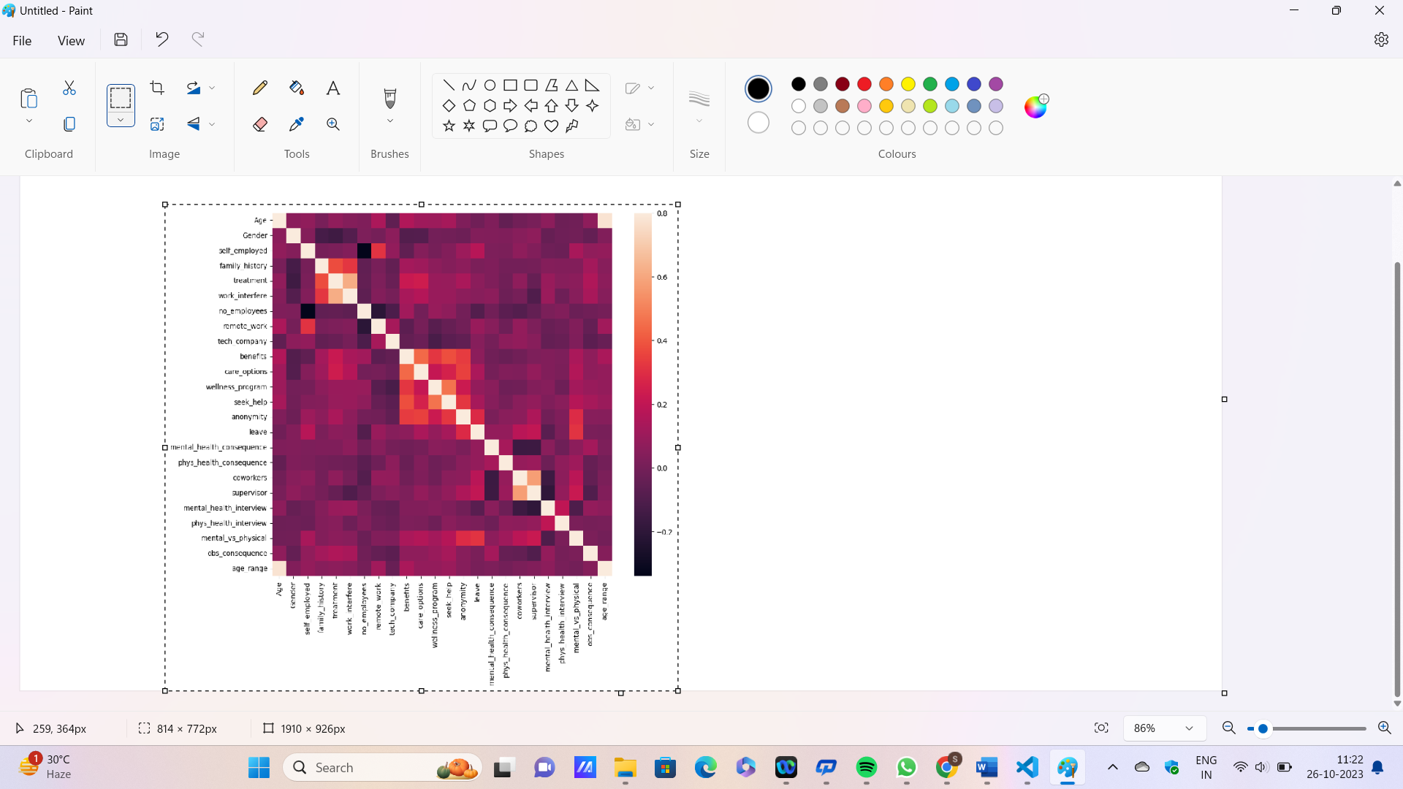

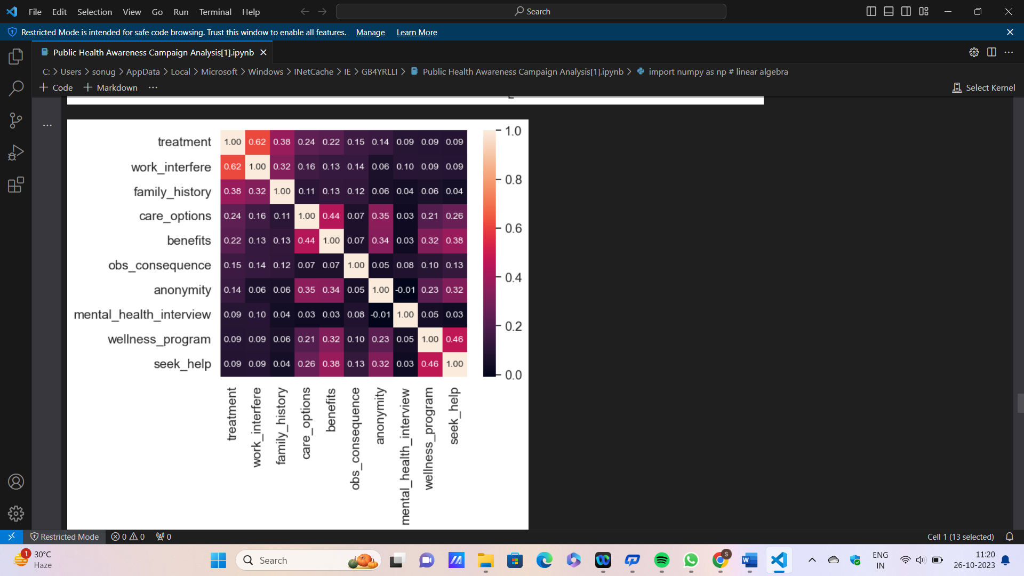

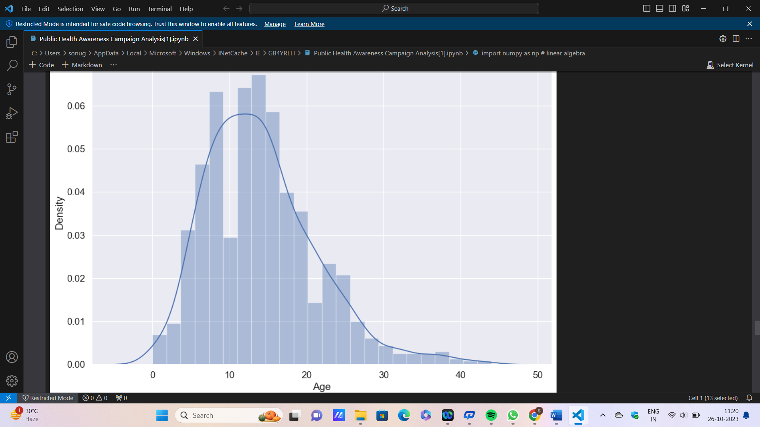

**CREATING DASHBORD USING IBM COGNOS :**

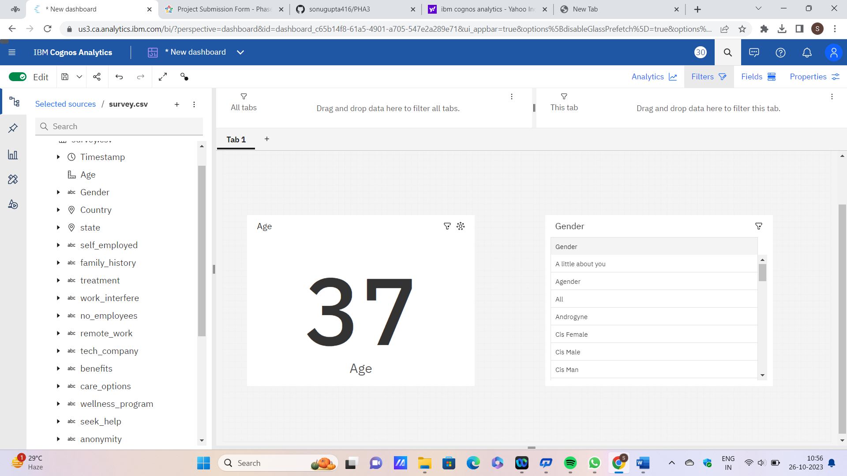

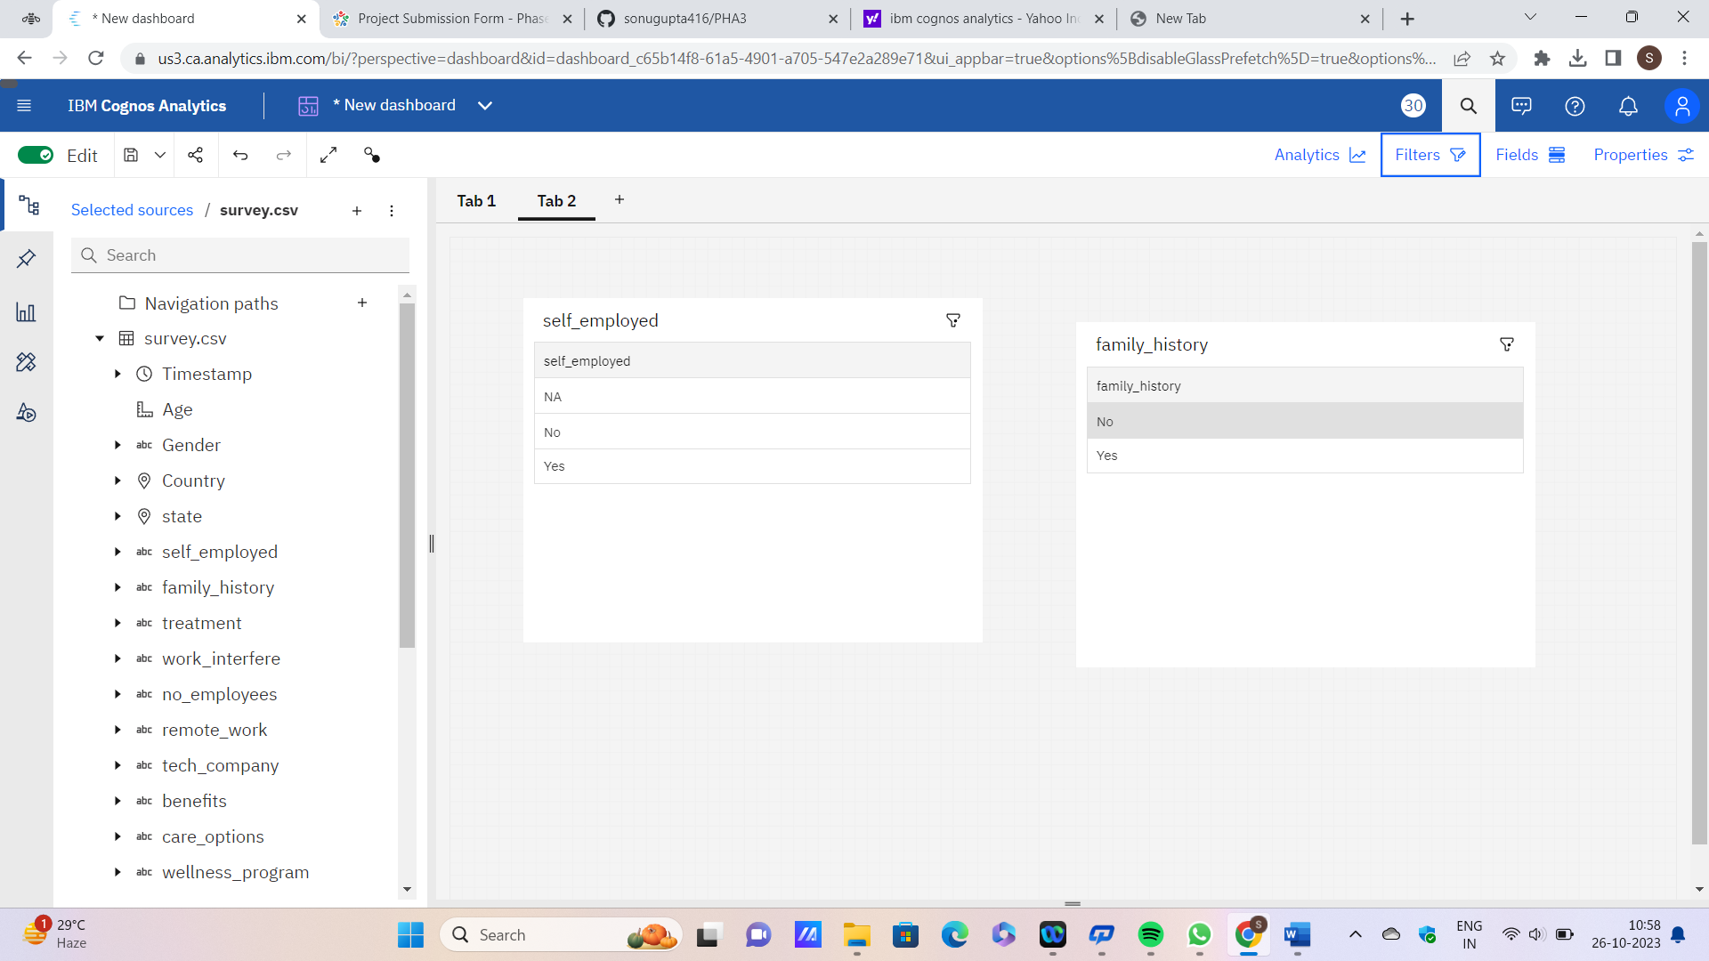

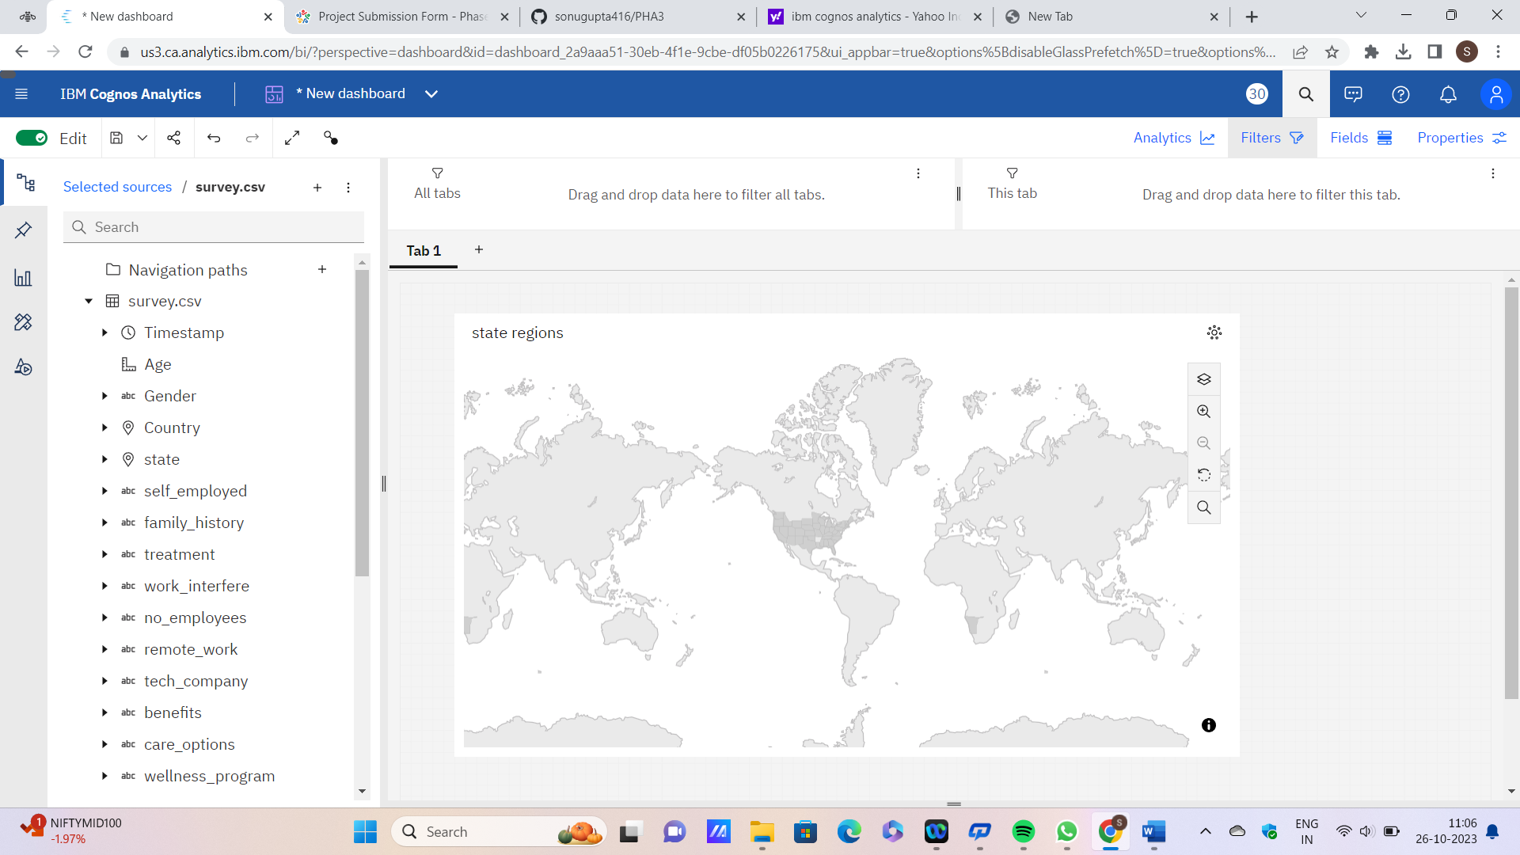

**CREATING REPORT USING IBM COGNOS :**

